Construction Lumber/Wood  10.16 x 10.16 x 365.76 – CM  Screws: 10.16 cm  Screws: 5.8 cm  Metal screws /bolts: 10.16 | 60 Pieces  800 Pieces  400-600 Pieces  600 Pieces | 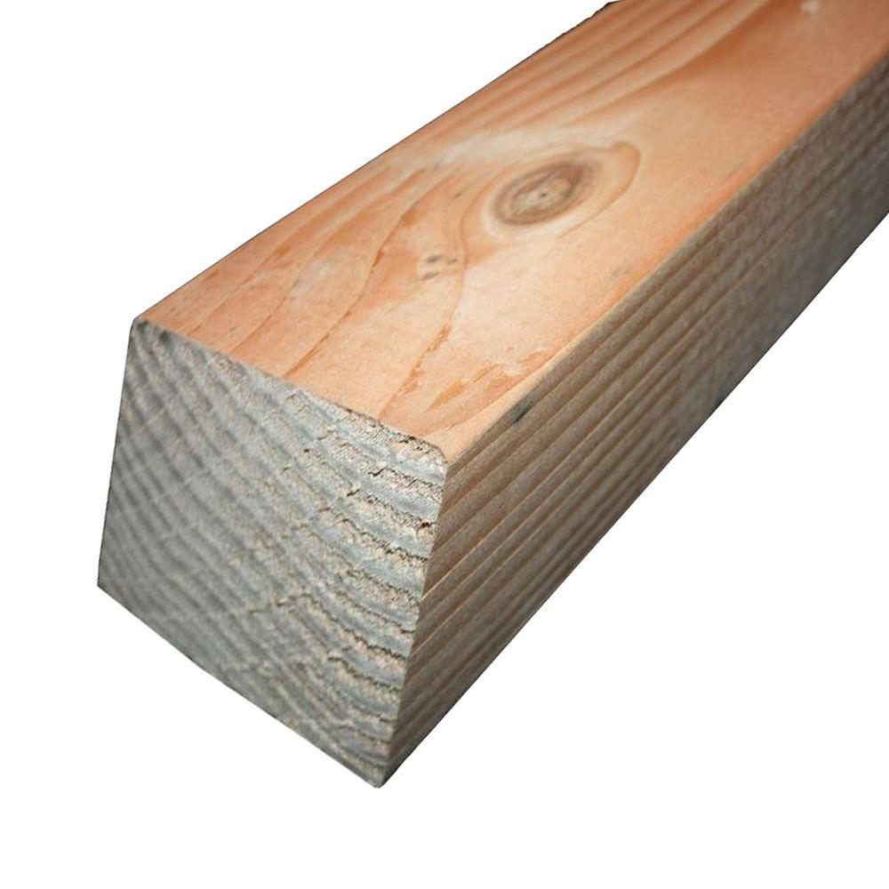
Construction Lumber/Wood  5.08 x 10.16 x 365.76 – CM | 120 Pieces | 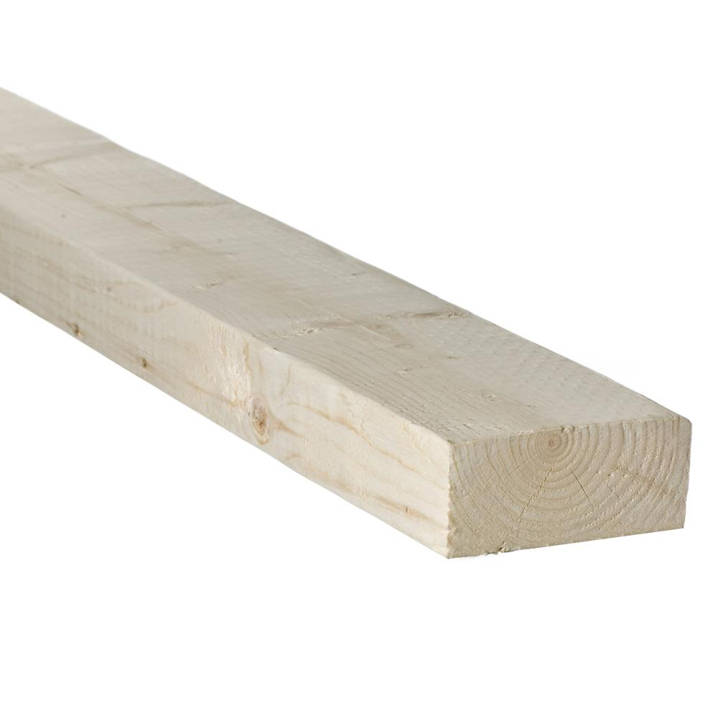
Decking boards  Decking Screws | 24 x 30 sq m  400 Pieces | 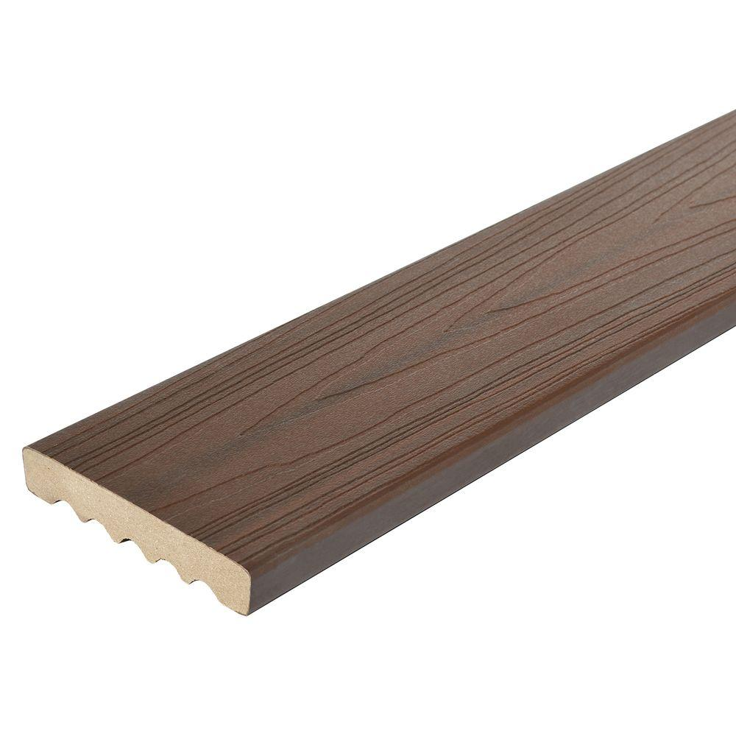
Rustic corrugated reclaimed metal shee
Pool Liner | 30 sq m |  | 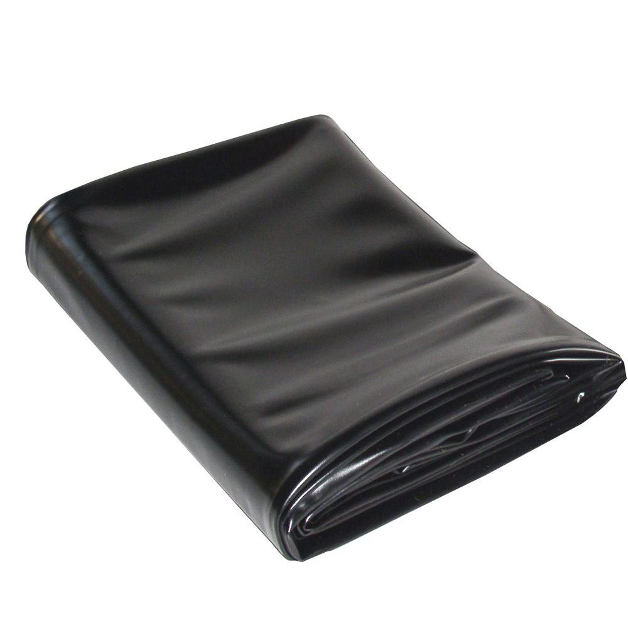
Pond Pad / Thin foam sheet | 22 sq m |  | 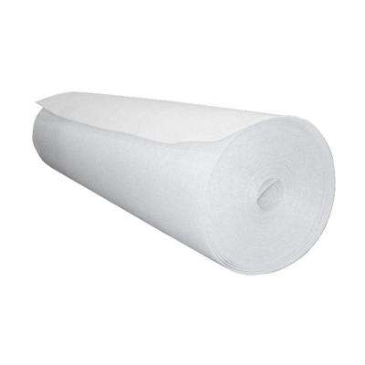
Burlap / Jute fabric in black color | 50 sq m |  | 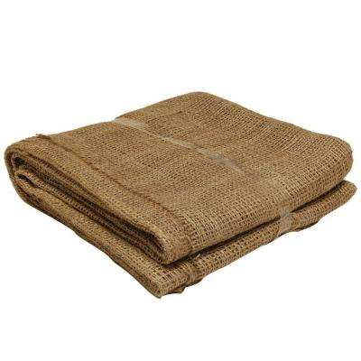
Stone slabs rustic/natural color  60.96 x 121.92 |  | 10 pieces |  | 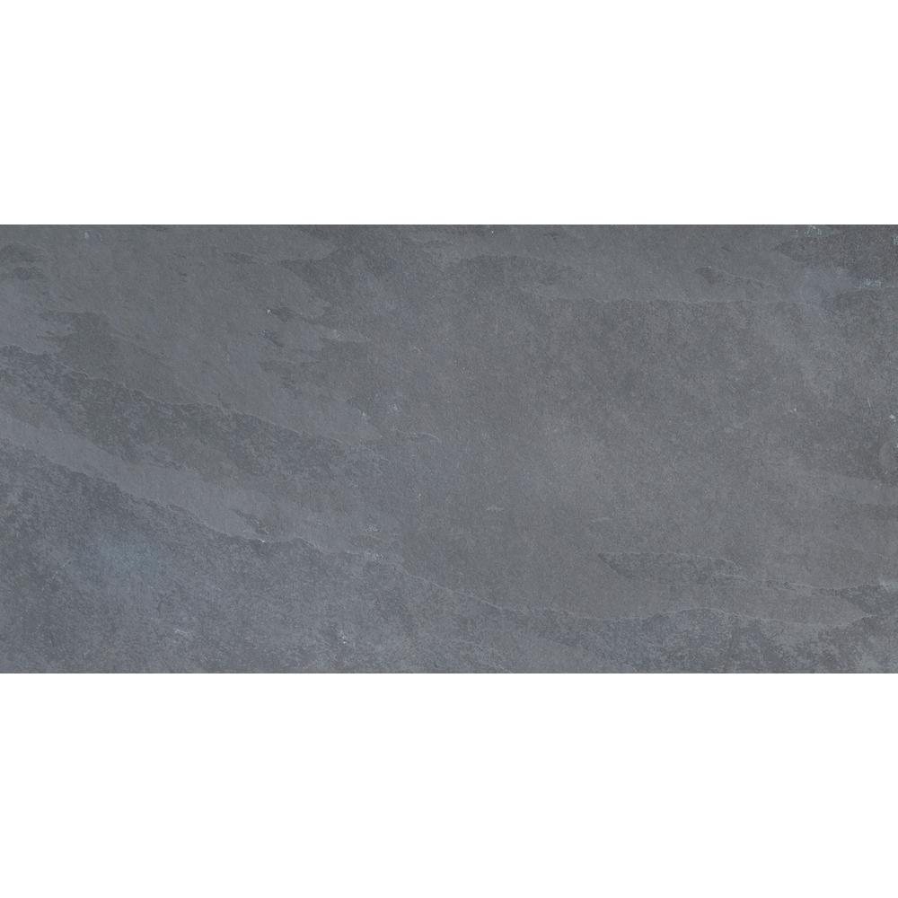
Garden lights for steps, trees, all plants.

Small Lights for inside the rooms. To create stars impact

Water Pump medium size

8-meter pipe with 4 joints.

Rustic corrugated metal panels / Or new depends on the availability:  121.92 x 243.84 cm |  | 30-34 pieces |  | 